Newspaper Process

Step 1 (Concierge)

In any screen from The Concierge Assistant double click the “QV’ icon in the upper left corner.

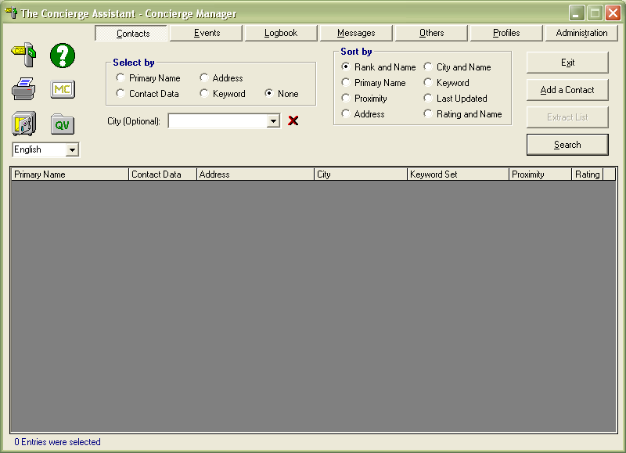

In the QV screen select by single clicking the “Concierge Daily Diary”

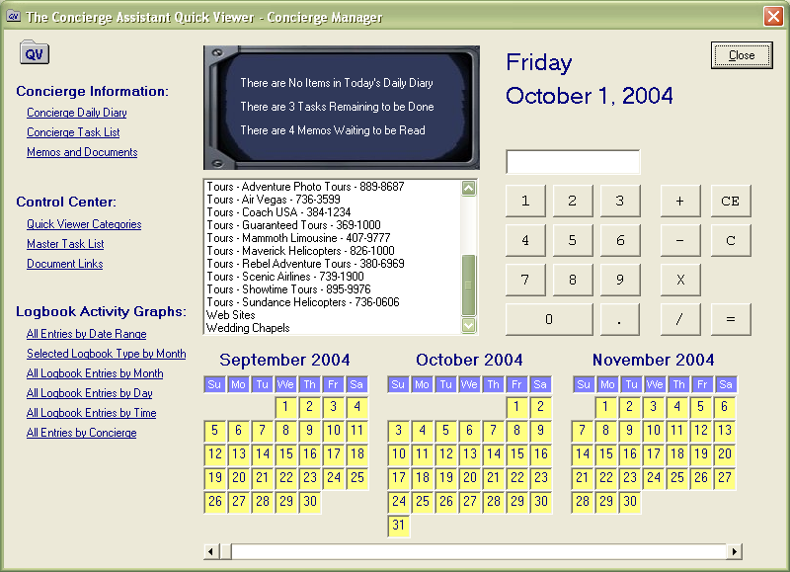

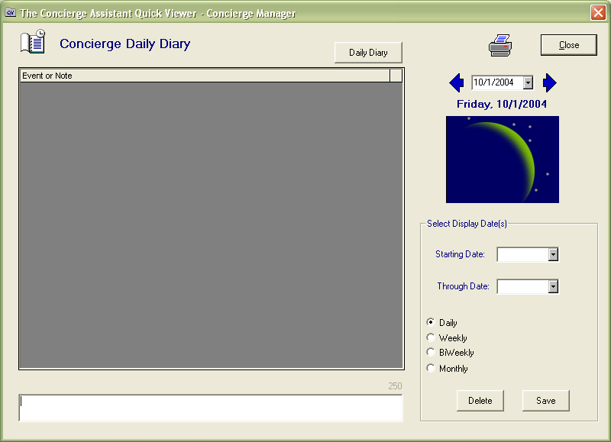
Type the name of the room number, last name of the guest and the type of desired newspaper.

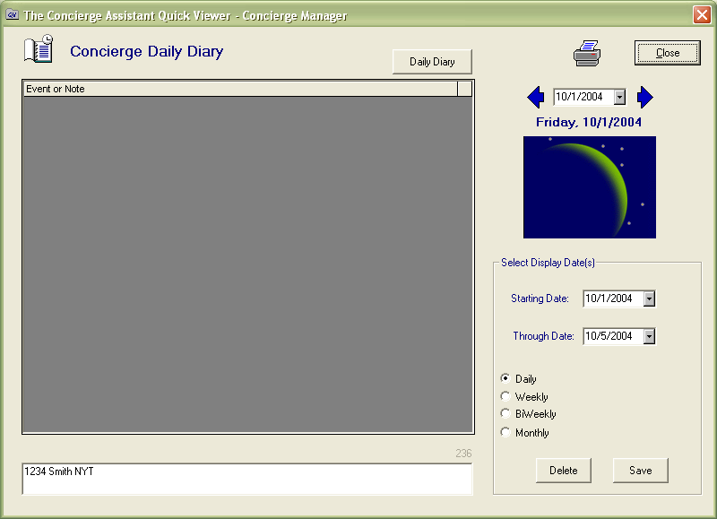

Select the “Start date” and “Through Date” and the frequency must be “Daily”
Click Save and you will see the entry in the list of events or notes

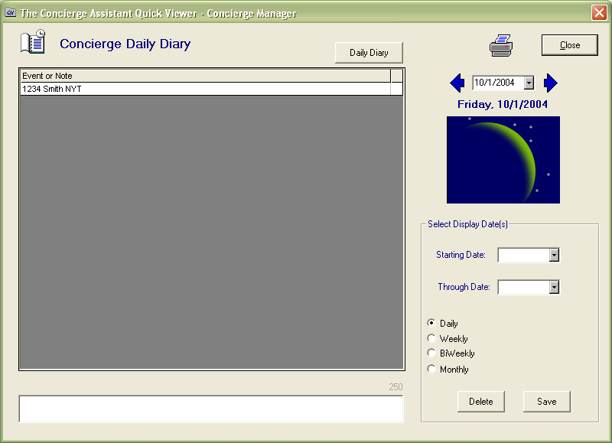

Step 2 (Guest Services Staff)

Log on in the Concierge Assistant as guest and hit the enter key as password

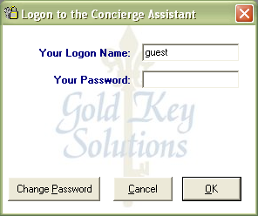

In any screen from The Concierge Assistant double click the “QV’ icon in the upper left corner.

In the QV screen select by single clicking the “Concierge Daily Diary”

Double click the printer icon and make sure that you get the desired date. (Today is the default)

You will see this report, click the printer icon and that’s it. You are ready to delivery your newpapers.

